Blessing the Dust  For Ash Wednesday  All those days  you felt like dust,  like dirt,  as if all you had to do  was turn your face  toward the wind  and be scattered  to the four corners  or swept away  by the smallest breath  as insubstantial—  did you not know  what the Holy One  can do with dust?  This is the day  we freely say  we are scorched.  This is the hour  we are marked  by what has made it  through the burning.  This is the moment  we ask for the blessing  that lives within  the ancient ashes,  that makes its home  inside the soil of  this sacred earth. | So let us be marked  not for sorrow.  And let us be marked  not for shame.  Let us be marked  not for false humility  or for thinking  we are less  than we are  but for claiming  what God can do  within the dust,  within the dirt,  within the stuff  of which the world  is made  and the stars that blaze  in our bones  and the galaxies that spiral  inside the smudge  we bear.  —Jan Richardson  From Circle of Grace: A Book of Blessings for the Seasons by Jan Richardson

We offer this heart with a blessing: that you may feel it in your pocket or see it on your table throughout Lent and remember God’s endless love for you—
with all your brokenness & beauty,
all your grief & gratitude,
all your worries & questions,
all your struggles & gifts.
You are never alone for nothing can separate you from the love of God.

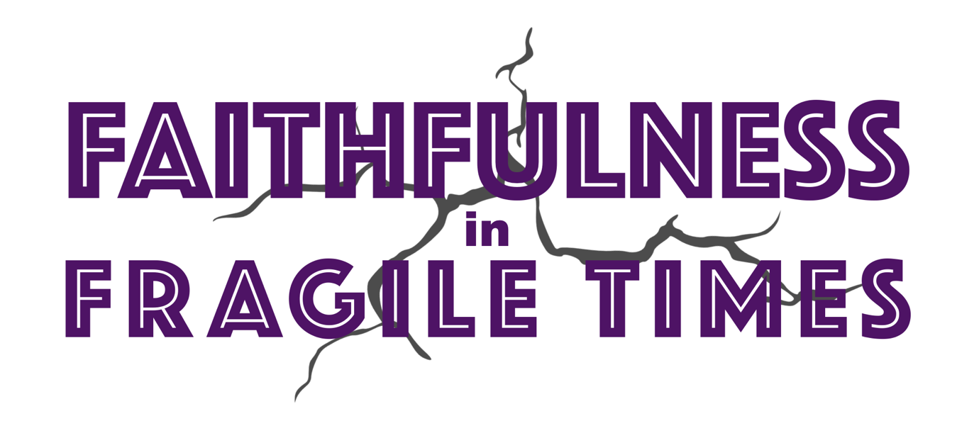
You are invited to join in worship & fellowship with us this Lent, Holy Week, and Easter. Our sermon series will focus on the central values & practices of our faith that get us through difficulty, as we lament those ills in our world like climate change, war, cynicism, domestic violence, poverty & housing costs, and more. How do we practice faithfulness together, in times that feel so fractured & fragile? Please visit vlmcc.org for more information about who we are & how we’ll practice together this Lent.

Vista La Mesa is part of the Christian Church (Disciples of Christ), which seeks to be a movement for wholeness in a fragmented world. As part of this larger work in the world, our first two Sundays in Lent will include a Special Offering for Week of Compassion, the relief, refugee, and development mission fund of the denomination.

A meditation:  We are dust & we are stardust  Made in the image of God  From earth & water  Air flowing through, connecting us by our breath  Feel your aliveness: Inhale-exhale | The weight of your body  The beat of your heart  You are here, you are now  And God is with you  Be Still & Know
Genesis 2: 4b-8
On the day the Lord God made earth and sky— ⁵ before any wild plants appeared on the earth, and before any field crops grew, because the Lord God hadn’t yet sent rain on the earth and there was still no human being to farm the fertile land, ⁶ though a stream rose from the earth and watered all of the fertile land— ⁷ the Lord God formed the human from the topsoil of the fertile land and blew life’s breath into his nostrils. The human came to life. ⁸ The Lord God planted a garden in Eden in the east and put there the human he had formed.

Reflection Questions
We can name different categories of sins: individual or communal.
- For personal sin: What have you done or left undone that lingers in your mind + heart + spirit? Name it to God now.
- For shared or structural sin: What evil in the world do you so want to change? Name it to God, and ponder how you interact with it.

For what else do you lament & cry out to God, why?!

Psalm 130
I cry out to you from the depths, Lord—
² my Lord, listen to my voice!
Let your ears pay close attention to my request for mercy!
³ If you kept track of sins, Lord—
my Lord, who would stand a chance?
⁴ But forgiveness is with you—
that’s why you are honored.
⁵ I hope, Lord.
My whole being hopes,
and I wait for God’s promise.
⁶ My whole being waits for my Lord—
more than the night watch waits for morning;
yes, more than the night watch waits for morning!
⁷ People, wait for the Lord!
Because faithful love is with the Lord;
because great redemption is with our God!
⁸ He is the one who will redeem people
from all our sin.

When life feels uncertain, what helps you remember & hold onto the ever-present love of God?
Lent can be a season of stripping away our usual comforts to see and hear more clearly. Often, we do this by giving something up or adding something that will help us feel more connected to God. Has this helped you before? Would you like to try something this Lent?

Isaiah 58: 6-12  Isn’t this the fast I choose:  releasing wicked restraints, untying the ropes of a yoke, setting free the mistreated, and breaking every yoke?  ⁷ Isn’t it sharing your bread with the hungry and bringing the homeless poor into your house, covering the naked when you see them, and not hiding from your own family?  ⁸ Then your light will break out like the dawn, and you will be healed quickly.  Your own righteousness will walk before you, and the Lord’s glory will be your rear guard.  ⁹ Then you will call, and the Lord will answer; you will cry for help, and God will say, “I’m here.”  If you remove the yoke from among you, the finger-pointing, the wicked speech;¹⁰ if you open your heart to the hungry, and provide abundantly for those who are afflicted, your light will shine in the darkness, and your gloom will be like the noon.  ¹¹ The Lord will guide you continually and provide for you, even in parched places. He will rescue your bones.  You will be like a watered garden, like a spring of water that won’t run dry.  ¹² They will rebuild ancient ruins on your account; the foundations of generations past you will restore.  You will be called Mender of Broken Walls, Restorer of Livable Streets. | As you go, a benediction:  Beloved wanderer,  as you leave this place,  may you carry your curious heart on your sleeve.  May you look for God in every face.  May you find the courage to get out of the boat,  to run to the tomb,  and to speak of your faith.  And when the world falls apart,  may you hear God’s voice deep within,  saying, “Take heart, it is I, be not afraid.”  You are called.  You are blessed.  In both your ups and your downs,  you always belong to God.  Go now in peace.  Go trusting that good news.  Amen.  Benediction by Rev. Anna Strickland | A Sanctified Art LLC | sanctifiedart.org

